**Lab Session 07**

**Apply the concepts of Packages**

**Date of the Session: Time of the Session:**

**Pre-Lab Tasks:**

**1. Define a package.**

**2. How does the Java run-time system know where to look for packages that you create?**

**3. Mention the benefits of packages.**

**4. What are the benefits of organising classes into packages?**

**5. What is static import?**

**In-Lab Tasks:**

1. Create a package with name placements. It consists of number_of_palcements class with one method called read_data to read year and the number of placements in that year. Now import placement package in your program and create an array of objects to store placement data in different year and compute total number of placements in all years.

**Test Case:**

***Test Case 1:***

***Input:***

Number of years 3

2019 200

2018 134

2017 234

***Output:***

Total Number of placements 568

***Test Case 2:***

***Input:***

Number of years 2

2014 200

***Output:***

Invalid Input

**Aim:**

To implement a package named placements that reads data from user and calculates total number of placements.

**Algorithm:**

1.Start.

2.Create a package with name as placements.

3.Inside the package, create a class with name NoOfPlacements that is used to read data from user.

4.Inside the class, create a method with name readData that is used to read the year, placements in the respective year.

5.Outside the package, create a class with name packPlacementsTest which contains main method.

6.Inside the main, create array of objects to read continous data from user.

7.Calculate the total number of placements and store in variable sum.

8.Display sum.

9.Stop.

**Source Code:**

**NoOfPlacements.java**

package placements;

import java.util.Scanner;

public class NoOfPlacements

{

Scanner sc=new Scanner(System.in);

public int year,place;

public void readData()

{

System.out.println("Enter year");

year=sc.nextInt();

System.out.println("Enter placements");

place=sc.nextInt();

return;

}

}

**PackPlacementsTest.java**

import placements.NoOfPlacements;

import java.util.Scanner;

class PackPlacementsTest

{

public static void main(String[] args)

{

Scanner sc=new Scanner(System.in);

int noOfyrs,sum=0;

System.out.println("Enter no of years");

noOfyrs=sc.nextInt();

NoOfPlacements[] np=new NoOfPlacements[noOfyrs];

for(int i=0;i<np.length;i++)

{

np[i]=new NoOfPlacements();

np[i].readData();

sum+=np[i].place;

}

System.out.println("Total number of placements "+sum);

}

}

**Output:**

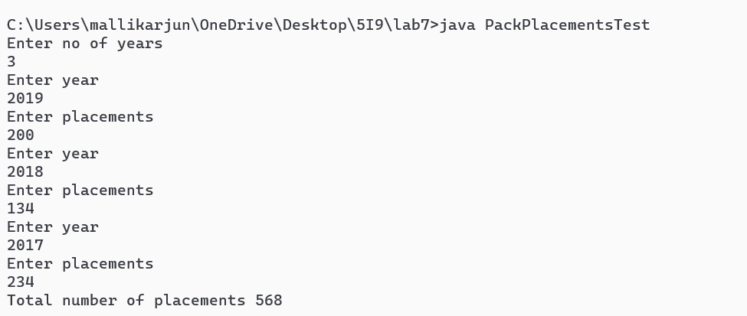

**Result:**

The program to find total number of placements using concepts of packages is successfully executed.

2.Create a package with name shape. It consists of Triangle, Rectangle, Square classes with attributes height and width. Import this package in your program and calculate area of each shape.

**Test Cases:**

***Test Case 1:***

***Input:***

20,20

***Output:***

Area of triangle: 200

Area of Rectangle: 400

Area of square: 400

***Test Case 2:***

***Input:***

20,40

***Output:***

Area of triangle: 400

Area of Rectangle: 800

Area of square: Invalid Dimensions

**Aim:**

To write a java program that creates a package named shape and calculate the area of each shape.

**Algorithm:**

1.Start.

2.Create a package named shape

3.Inside the package shape, create three classes namely Rectangle, Square, Triangle with one method.

4.Keep the method name as area that finds the area of each shape respectively.

5.Outside the package, create a class named CalcArea that imports the package shape and calculates area

6.This class contains the main method.

7.Prompt the user to input height and width and pass these values to each class in package.

8.Create objects to call area method and display the area.

9.Stop.

**Source Code:**

**Rectangle.java**

package shape;

public class Rectangle

{

int width,height;

public Rectangle(int h,int w)

{

width=w;

height=h;

}

public void Area()

{

System.out.println("Area of rectangle is:"+(width*height));

}

}

**Triangle.java**

package shape;

public class Triangle

{

int width,height;

public Triangle(int h,int w)

{

width=w;

height=h;

}

public void Area()

{

System.out.println("Area of triangle:"+((width*height)/2));

}

}

**Square.java**

package shape;

public class Square

{

int width,height;

public Square(int h,int w)

{

width=w;

height=h;

}

public void Area()

{

if(height==width)

System.out.println("Area of Square is:"+(width*height));

else

System.out.println("Area of square:Invalid Dimensions");

}

}

**CalcArea.java**

import shape.*;

import java.util.Scanner;

class CalcArea

{

public static void main(String[] args)

{

Scanner sc=new Scanner(System.in);

int w,h;

System.out.print("Enter width ");

w=sc.nextInt();

System.out.print("Enter height ");

h=sc.nextInt();

Triangle t=new Triangle(w,h);

Rectangle r=new Rectangle(w,h);

Square s=new Square(w,h);

t.Area();

r.Area();

s.Area();

}

}

**Output:**

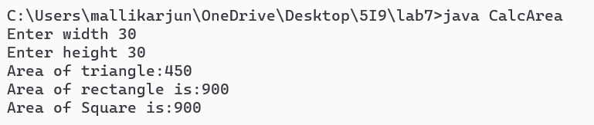

**Result:**

Java program to calculate area of different shapes is successfully executed.

**Post-Lab Tasks:**

1. Create a package called restaurant with two classes named menu and bill. Create class called customer which imports menu and Bill classes form package.

**Aim:**

To implement restaurant using concept of packages.

**Algorithm:**

1.Start.

2.Create a package named as restaurant.

3.Inside the package, create two classes Menu, Bill that displays simple message.

4.Outside the package, create a class Customer class that import restaurant package.

5.Create objects for the respective classes and display the message.

6.Stop.

**Source Code:**

**Menu.java**

package restaurant;

public class Menu

{

public void MenuMessage()

{

System.out.println("Menu displayed.");

}

}

**Bill.java**

package restaurant;

public class Bill

{

public void BillMessage()

{

System.out.println("Bill printed.");

}

}

**Customer.java**

import restaurant.*;

public class Customer

{

public static void main(String[] args)

{

Bill b=new Bill();

Menu m=new Menu();

m.MenuMessage();

b.BillMessage();

}

}

**Output:**

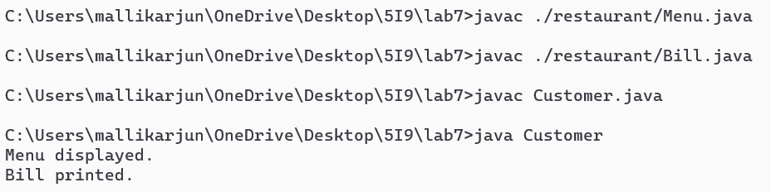

**Result:**

The program is successfully executed and got verified.

**Student’s Signature**

***(For Evaluator’s use only)***

**Marks Secured: _________ out of __________**

**Faculty Signature**